CYBS 7359 - Digital Forensics
Final Exam
Spring 2023

NAME: CHRISTOPHER PHAN
STUDENT ID: 900884326

I certify that this is my own work and I have cited all work that is not mine by quotes and citation or by paraphrasing with citations using APA. I understand that if I have plagiarized or copied materials that are not my own work that I will fail this exam with a grade of zero and be subject to academic review. This includes cutting and pasting.

NAME: CHRISTOPHER PHAN
DATE: April 12, 2023
- In December 2022, Ermenildo Castro, a software developer at Zulily was charged with stealing more than $300K from the company by routing fraudulently imposed shipping fees to his personal account and reducing the cost of his purchases. Analyze this case from a digital-forensics perspective. Write a report about the incident focusing on the digital forensics processes employed to uncover the evidence against Castro.
  - Description/introduction of the incident
    - Software engineer, Ermenildo Valdez Castro, was siphoning money illegally from his company, Zulily. He stole around $300,000 from Zulily by manipulating product prices, shipping fees, and diverting the funds from that to his account. The main three methods of getting these funds were through (1) diverting shipping costs from Zulily’s account to his own, (2) inputting a replacement code that double-charged customers for the missing shipping cost, allowing Castro to siphon off more money from Zulily, and (3) reducing the price point of items to pennies per unit, which then Castro purchased. His reduction of the price point for multiple items is what caught Zulily’s attention, as it was tied to his address and card, and the cost of the items was extremely reduced.
  - Summary of charges filed
    - Castro was charged with 2 counts of theft in the first degree and 1 count of identity theft in the first degree.
  - Processes/tools used to gather evidence for these charges
    - The process that allowed Zulily’s discovery of Castro’s malicious actions was the steep price adjustments and how the items that have been adjusted were bought by Castro and shipped to his address. The price adjustment was extreme as Castro had bought over 1,000 items, which were originally priced over $40,000 altogether, and had been changed to a measly $250. These items would come to Castro’s residence in batches, creating a continuous pattern for Zulily. Zulily’s corporate security team went to Castro’s residence and found the pile of items stacked in front of his home. After he was caught with large-scale ordering, his account was investigated in Zulily’s database, discovering that he was in contact with an unauthorized payment processor, Stripe, Inc. Though Stripe, Castro was able to skim the payments made from Zulily’s website and put it in his personal bank account. Upon investigation of Castro’s work laptop, his plan was discovered as a document detailing the “OfficeSpace project”, describing his entire plan of how he was going to steal money from Zulily.
  - Lessons learned – how would you use the insights from this case to inform your company to stay on the lookout for employee fraud?
    - Insights made from Castro’s case are to avidly monitor employee communications as well as files that they keep on their work tech property (such as company laptops). As well, especially when there is a discrepancy between information, where consumers are receiving extra unexplainable fees that they should not be receiving originally. As well, there should have been controls placed on the website's payment processors and price alterations, such as immediate alerts made when the price has been changed or alerts on changes of coding on the payment processing. When these alerts are made, it details what changes have been made and by who. As well, there should have been a control system that stopped the implementation of the code made by Castro that needed to be signed off by a higher-up or a peer for review. Zulily placed too much trust and power in employees, allowing the system to be easily abused, if Castro did not mistakenly allow the orders to be paid for and shipped, he may have been undiscovered for many months or years.

- Lab 6: Conducting Forensic Examination on Linux Systems
  - Using the Internet, research the location of the log file that Linux uses to keep track of printing records. Next, use E3 to access that log file and display the contents in the Document View. Provide a screenshot showing the contents of the printer log file, and cite your sources for Internet research.
    - 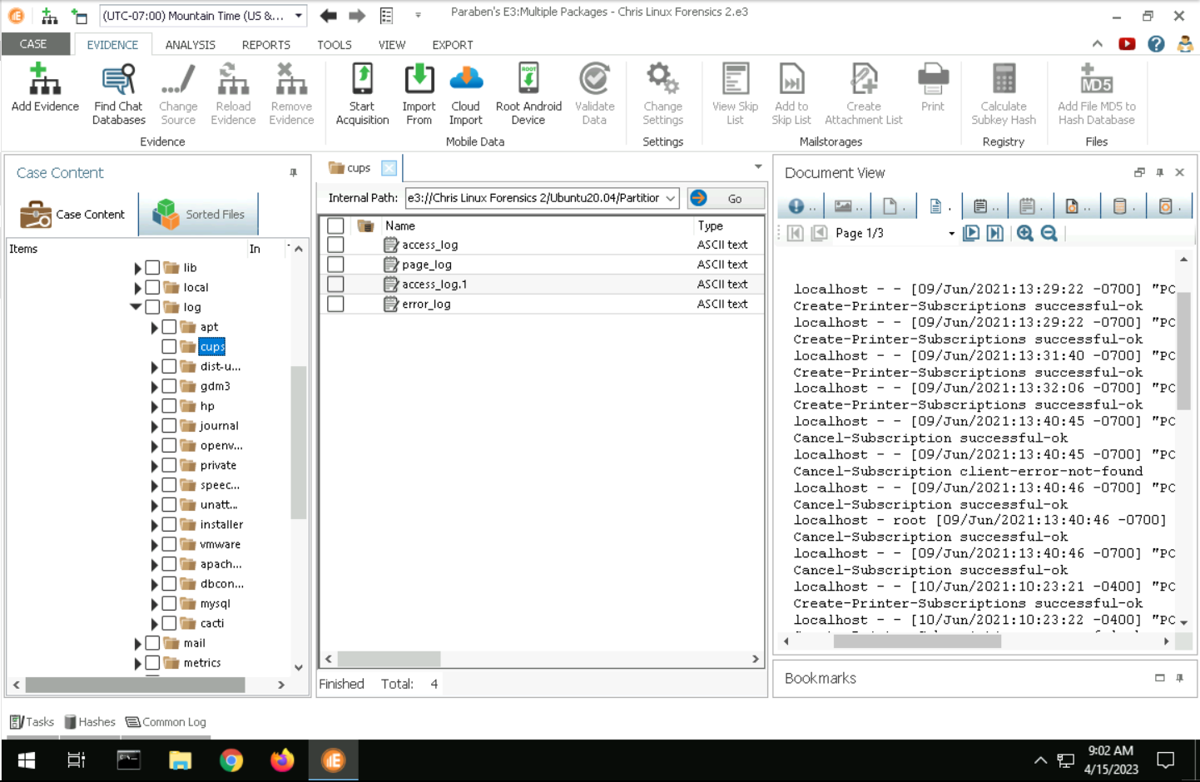
  - Using the Internet, research the syntax and arguments used for the dd command. Next, use E3 to run an Advanced Search on the /var/log folder for any records of the dd command being run. Provide a screenshot showing the record of the dd command in the Text View, and cite your sources for Internet research.
    - 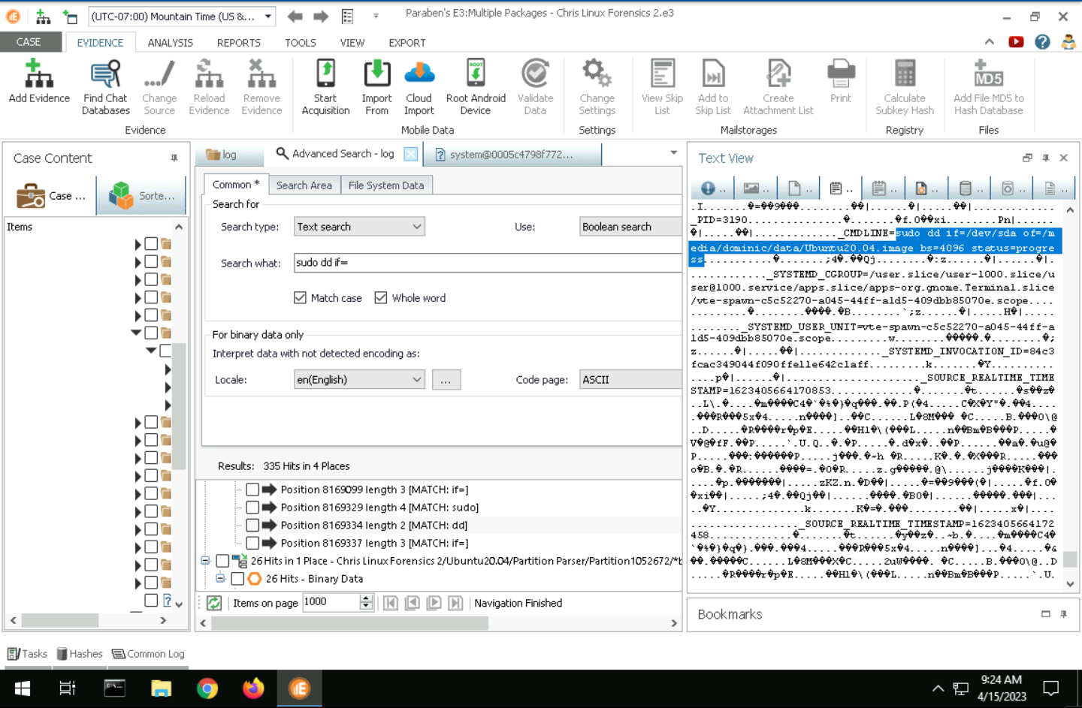
  - Among the results, you should see a file titled kern.log. What is the relevance of this file to any forensics investigation process? Provide a screenshot documenting the contents of the kern.log file.
    - 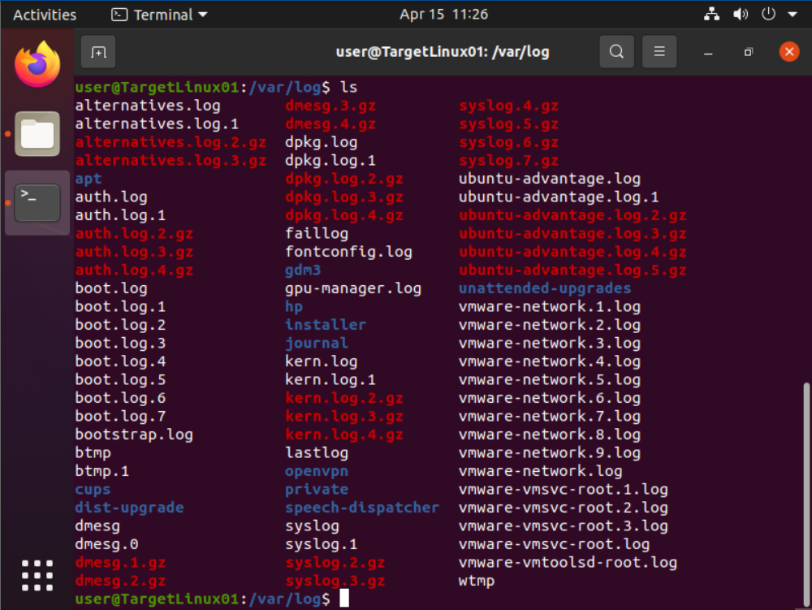
    - A kern.log file can tell you what drivers have been loaded or offloaded, the status of those drivers, if any of the startup systems have been tampered with, and if there have been hardware errors. Kern.log files are also valuable for a forensics investigation in particular due to these logs being able to detail if there has been malicious activity such as malware that needs to interact with the system may interact with a kernel, as well malicious files may try to hide in the operating systems or software like rootkits. Kernels can be used for hiding the presence of both malicious actors and malware.

- Learning Activities related to forensics tools.
  - In Unit 11, you read a research article on how memory forensics can lead to clues about what users browse in private browsing mode. List and describe any two of these.
    - RAM forensics, based on the article, have nullified the claims made by web browsing companies that PBM hides users’ history and actions. The article authors used Redline, a RAM capture (Collector) and analysis (Memoryze) tool, using a USB drive as an entry point to a targetted endpoint.
      - Evidence of cookies is still left behind, even if the PBM user has deleted the cookies after closing, they trace that a deletion of these pieces of data has occurred, giving the context of the user’s action in the PBM. These cookies contain usernames and passwords, a way for websites to identify users to a specific network or endpoint.
      - As well, many of these web browsers claim that when you close the PBM, everything is deleted, though this does not hold true as web history, downloads, and search history is still kept through HTML residue. As well, whenever a user accesses a secure website, they have to go through a digital certificate that registers when access was made and to where. With the downloads, the investigators were able to determine what the file name is, what kind of file it is, and the size of the file. Even though the instance of PBM is closed, some indications show that a PBM was used and the history behind that PBM.
      - Email communications made on PBM are still able to be captured and monitored beyond the closing of the web browser. What can be traced is beyond simply context but can also analyze the content, as it can be seen who is communicating and what was said in the communication. Also, passwords to access these emails were also retrievable.
  - In Unit 7, you watched a SANS video on incident response in the cloud. The video mentioned the AWS shared responsibility model. Describe this model and its implications for work in digital forensics. How can the cloud offer better forensics capabilities?
    - The AWS Shared Responsibility model detail that the responsibility of security is shared between Amazon and its customers, Amazon secures the infrastructure of the cloud while customers are in charge of securing their own applications and data that are within AWS. What this model has for implication in digital forensics is the division of responsibility, allowing for more specified analysis of logs for both Amazon and their customers. As well, with AWS cloud tools, such as Cloud Trail, CloudWatch, S3, and such, organizations now have ease of access to tools for monitoring, modifying, scaling, and building security measures and instances. With the AWS Shared Responsibility model, digital forensics can become extremely more efficient, as now these tools that are available to organizations can become much more granular and controlled. Logging information can be easier to attain, and that information is stored in one singular place, allowing that data to be analyzed easier as it is stored in the cloud rather be in multiple different instances. Information is much more open in AWS, and logs are automatically being monitored and tracked rather than necessity of being toggled on. As well, AWS beats on-prem implementation as it is highly mobile and has greater ease of installation and modification for an organization.
  - In this course, you have used multiple forensics tools in the labs. You have also read about other tools in the research articles and watched videos on additional tools and best practices. For each of the following, what do you think is the best tool and why?
    - Cellphone forensics
      - For mobile devices, I believe that E3 is the best tool for this type of forensics. E3 has been shown that it can read and analyze data from mobile devices well, can categorize the data made from mobile devices and the applications installed, as well look into deleted files and recover them. Also, there are optional functions to do advanced data analysis on the contents of the phone, from emails, web searches, messaging apps, and files that are being held within the phone’s database. E3 also developed a mobile device analyzer specialist called Paraben that’s part of E3 functions, allowing for further examination of mobile device data. E3 has shown to be a great resource for digital forensics for mobile and immobile devices, capable of preserving the integrity of the data and isolating the information.
    - Memory forensics
      - Based on what we have seen for memory forensics we have dealt with in the course, E3 and Volatility are capable of analyzing memory dumps. The issue with either of these tools is that E3 does not specialize in memory forensics, and Volatility, a flexible and highly customizable memory forensics tool for command, is extremely far from having a user-friendly interface in its analysis. As shown from the article that was for question 3A, Redline seems to be a highly reliable RAM analyzer, as it can do both memory capture and memory investigation. Redline, much different than Volatility’s command-line interface, has an actual user interface giving investigators greater ease of use for FireEye’s memory forensics tool. Redline is also capable of different methods (such as different categories of information collecting and IoC investigation) for comprehensive memory analysis with its base model, while Volatility will need to have plug-ins installed to be at the same kind of operating level. The results of Redline are much easier to examine rather than Volatility’s and in tandem with the User Manual that is publicly produced by FireEye, Redline takes much less effort to understand and master, giving forensics investigators greater efficiency in finding evidence.
- From the vWorkstation, launch Google Chrome and navigate to corporationtechs.com/fixIt.exe (Note: fixIt.exe is case-sensitive), then download and run the executable. Next, review the pfSense firewall logs to identify the connection attempt made after downloading the malicious file. Provide a screenshot of the outgoing connection attempt that records the destination IP address and port number of the outgoing connection attempt. What kind of firewall ruleset would you advocate to mitigate the issues caused by outgoing connections?
  - 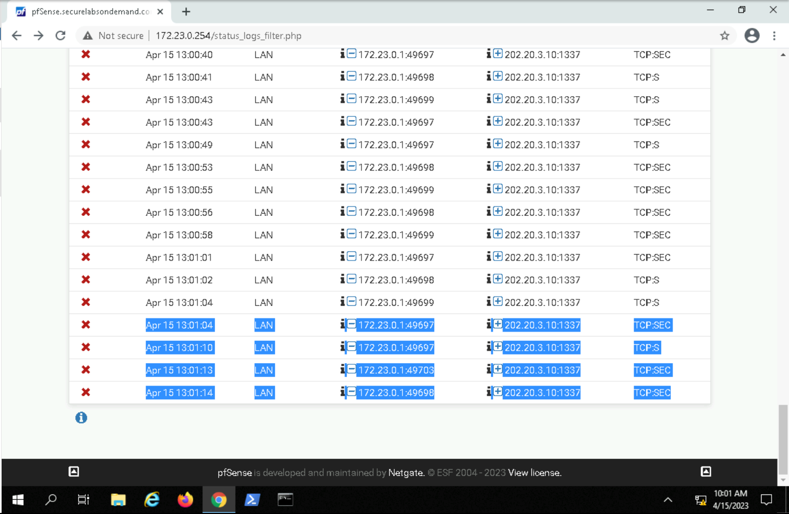
  - The firewall rulesets that I would advocate for are allowing only known outbound connections that are necessary for operations and blocking all other connections, blocking known malicious ports and protocols, restricting all inbound and outbound traffic to be able to connect only certain defined locations, and having permanent logs of all outbound connections for monitoring purposes.

- Using E3, explore the other conversations in the Discord data to identify another conversation related to drug trafficking. Make a screen capture showing the additional evidence within the Discord database.
  - 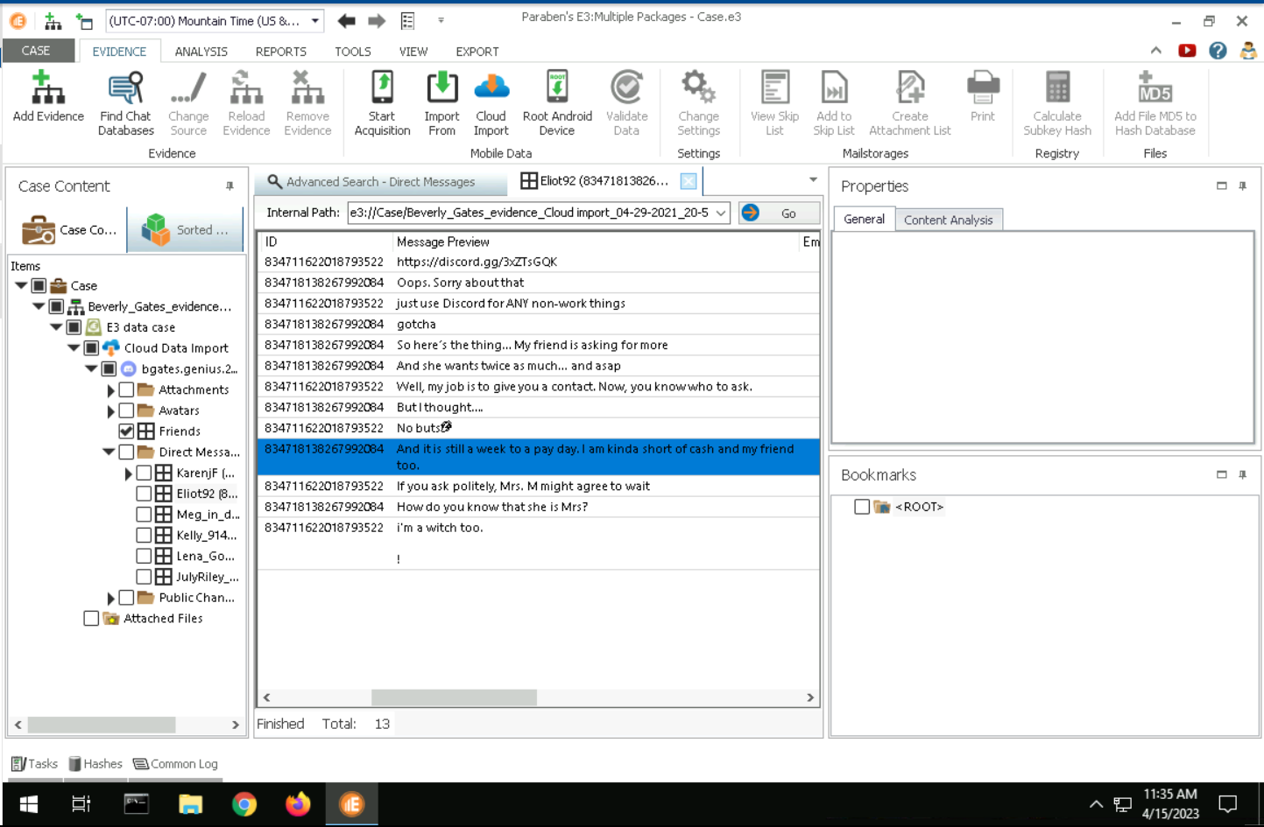
    - Elliot92 can be connected to drug trafficking as they are mentioning they are a contact for a certain object, stating how a friend needs more of a certain item, and “Mrs. M”, which has been a person of interest that has been mentioned by different people in Discord. Also the word “witch” seems to have an unestablished meaning, possibly referring to a drug dealer, and “witch” being referenced by other users.
  - 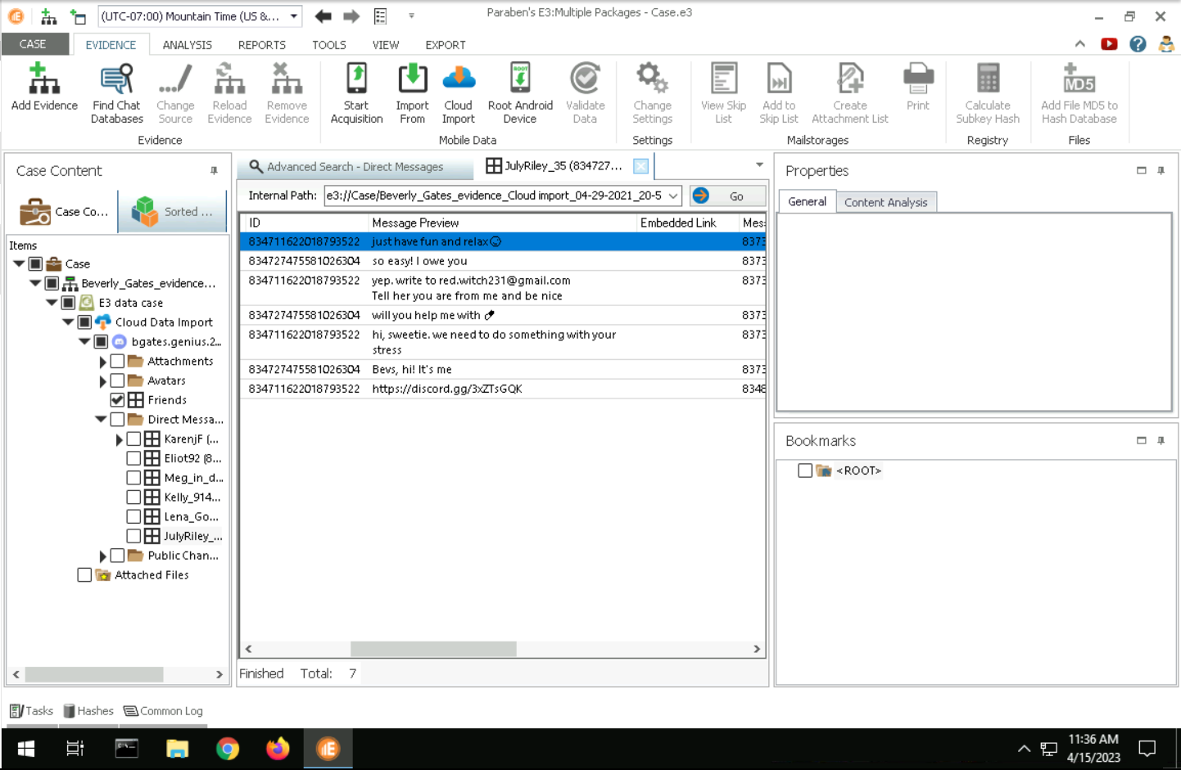
    - The email has the word “witch” in it’s address, which could signify a drug dealer in these Discord circles, as other users have referenced the word “witch”.
  - 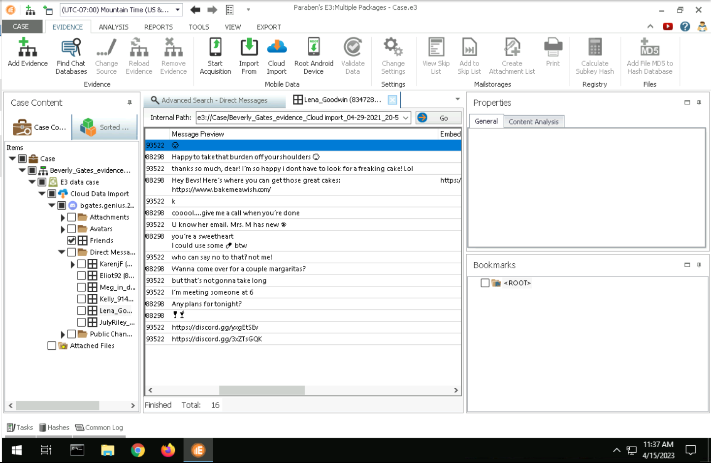
    - Mrs. M is mentioned again with the possibility of a new drug for circulation, as there is a new emoji being used in these Discord circles.
References
Ghafarian, A., & Amin, S. (2015). Analysis of privacy of private browsing mode through memory forensics. International Journal of Computer Applications, 132(16), 27–34. https://doi.org/10.5120/ijca2015907693
Kernel rootkits. Kernel Rootkits - an overview | ScienceDirect Topics. (n.d.). Retrieved April 15, 2023, from https://www.sciencedirect.com/topics/computer-science/kernel-rootkits
Linux DD command - 18 examples with all options. LinuxOPsys. (2022, June 11). Retrieved April 15, 2023, from https://linuxopsys.com/topics/linux-dd-command-with-examples
REDLINE USER GUIDE RELEASE 2.0. FIREEYE. (2020). Retrieved April 16, 2023, from https://fireeye.market/assets/apps/211364/documents/877936_en.pdf
Revers3r. (2016, April 14). Forensic investigation with redline. Infosec Resources. Retrieved April 16, 2023, from https://resources.infosecinstitute.com/topic/forensic-investigation-with-redline/
Ubuntu Manual - cupsd-logs. Ubuntu Manual. (n.d.). Retrieved April 15, 2023, from https://manpages.ubuntu.com/manpages/bionic/man5/cupsd-logs.5.html#:~:text=cupsd(8)%20normally%20maintains%20three,track%20pages%20that%20are%20printed.
What is the linux kernel? Red Hat - We make open source technologies for the enterprise. (2019, February 27). Retrieved April 15, 2023, from https://www.redhat.com/en/topics/linux/what-is-the-linux-kernel

